Project Design Phase
Solution Architecture

Date | 9 February 2026
Team ID | LTVIP2026TMIDS24222
Project Name | Flavour Fusion: AI-Driven Recipe Blogging
Maximum Marks | 4 Marks

Solution Architecture:
Solution architecture is a complex process – with many sub-processes – that bridges the gap between business problems and technology solutions. Its goals are to:
- Find the best tech solution to solve existing business problems.
- Describe the structure, characteristics, behavior, and other aspects of the software to project stakeholders.
- Define features, development phases, and solution requirements.
- Provide specifications according to which the solution is defined, managed, and delivered.

Solution Architecture Diagram:
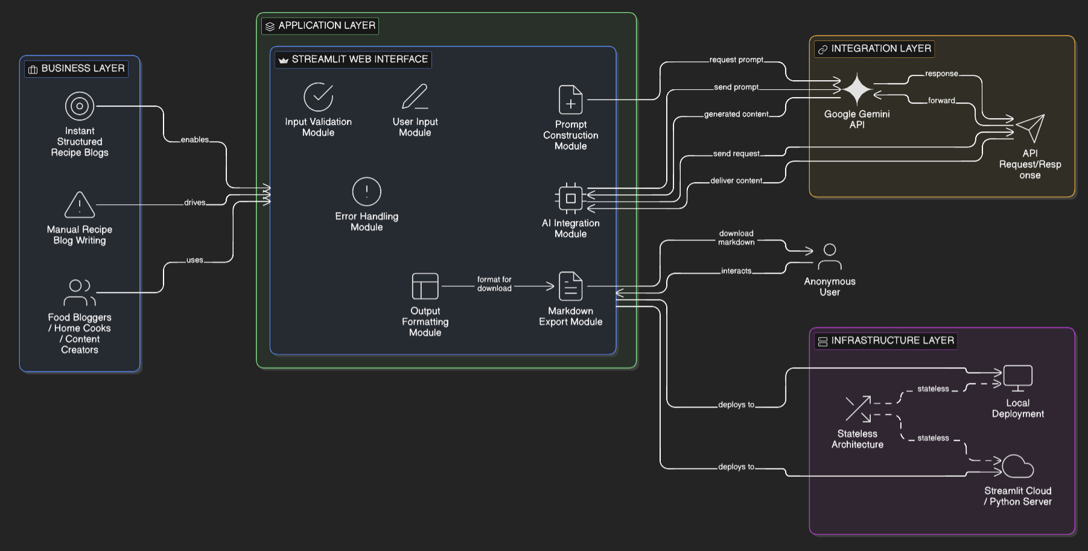
Figure 1: Architecture and data flow of the Flavour Fusion sample Web application

